Solution

Overview

**Realizing This is a Dynamic Programming Problem**

There are two parts to this problem that tell us it can be solved with dynamic programming.

First, the question is asking for the "number of ways" to do something.

Second, we need to make decisions that may depend on previously made decisions. In this problem, we need to decide what color we should paint a given post, which may change depending on previous decisions. For example, if we paint the first two posts the same color, then we are not allowed to paint the third post the same color.

Both of these things are characteristic of dynamic programming problems.

**A Framework to Solve Dynamic Programming Problems**

A dynamic programming algorithm typically has 3 components. Learning these components is extremely valuable, as **most dynamic programming problems can be solved this way**.

First, we need some function or array that represents the answer to the problem for a given state. For this problem, let's say that we have a function totalWays, where totalWays(i) returns the number of ways to paint i posts. Because we only have one argument, this is a one-dimensional dynamic programming problem.

Second, we need a way to transition between states, such as totalWays(3) and totalWays(4). This is called a **recurrence relation** and figuring it out is usually the hardest part of solving a problem with dynamic programming. We'll talk about the recurrence relation for this problem below.

The third component is establishing base cases. If we have one post, there are k ways to paint it. If we have two posts, then there are k * k ways to paint it (since we are allowed to paint have two posts in a row be the same color). Therefore, totalWays(1) = k, totalWays(2) = k * k.

**Finding The Recurrence Relation**

We know the values for totalWays(1) and totalWays(2), now we need a formula for totalWays(i), where 3 <= i <= n. Let's think about how many ways there are to paint the i^{th}*ith* post. We have two options:

1. Use a different color than the previous post. If we use a different color, then there are k - 1 colors for us to use. This means there are (k - 1) * totalWays(i - 1) ways to paint the i^{th}*ith* post a different color than the (i - 1)^{th}(*i*−1)*th* post.
2. Use the same color as the previous post. There is only one color for us to use, so there are 1 * totalWays(i - 1) ways to paint the i^{th}*ith* post the same color as the (i - 1)^{th}(*i*−1)*th* post. However, we have the added restriction of not being allowed to paint three posts in a row the same color. Therefore, we can paint the i^{th}*ith* post the same color as the (i - 1)^{th}(*i*−1)*th* post **only if** the (i - 1)^{th}(*i*−1)*th* post is a different color than the (i - 2)^{th}(*i*−2)*th* post.

So, how many ways are there to paint the (i - 1)^{th}(*i*−1)*th* post a different color than the (i - 2)^{th}(*i*−2)*th* post? Well, as stated in the first option, there are (k - 1) * totalWays(i - 1) ways to paint the i^{th}*ith* post a different color than the (i - 1)^{th}(*i*−1)*th* post, so that means there are 1 * (k - 1) * totalWays(i - 2) ways to paint the (i - 1)^{th}(*i*−1)*th* post a different color than the (i - 2)^{th}(*i*−2)*th* post.

Adding these two scenarios together gives totalWays(i) = (k - 1) * totalWays(i - 1) + (k - 1) * totalWays(i - 2), which can be simplified to:

totalWays(i) = (k - 1) * (totalWays(i - 1) + totalWays(i - 2))

This is our recurrence relation which we can use to solve the problem from the base cases.

Approach 1: Top-Down Dynamic Programming (Recursion + Memoization)

**Intuition**

Top-down dynamic programming starts from the top and works its way down to the base cases. Typically, this is implemented with recursion and then made efficient using *memoization*. Memoization refers to storing the results of expensive function calls to avoid duplicate computations - we'll soon see why this is important for this problem. If you're new to recursion, check out the [recursion explore card](https://leetcode.com/explore/featured/card/recursion-i/).

We can implement the function totalWays(i) as follows - first, check for the base cases we defined above totalWays(1) = k, totalWays(2) = k * k. If i >= 3, use our recurrence relation: totalWays(i) = (k - 1) * (totalWays(i - 1) + totalWays(i - 2)). However, we will run into a major problem - repeated computation. If we call totalWays(5), that function call will also call totalWays(4) and totalWays(3). The totalWays(4) call will call totalWays(3) again, as illustrated below, we are calculating totalWays(3) twice.

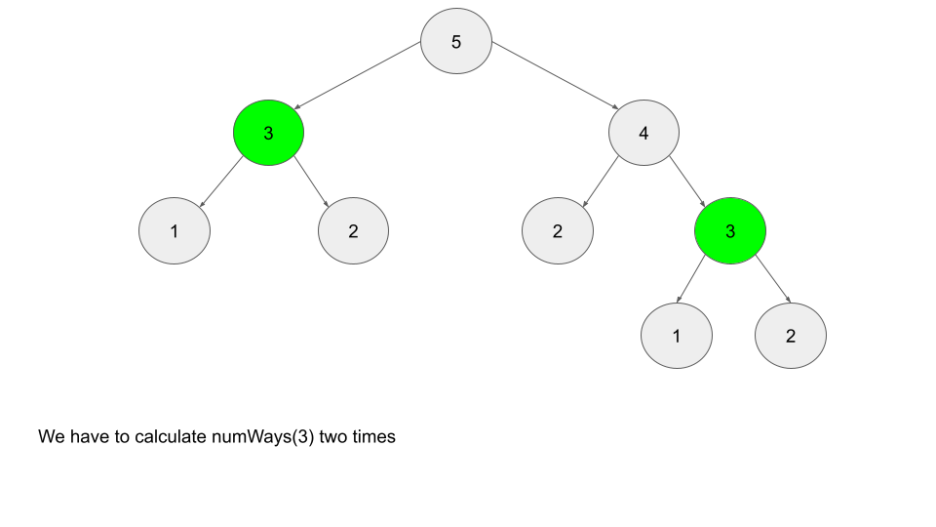

This may not seem like a big deal with i = 5, but imagine if we called totalWays(6). This entire tree would be one child, and we would have to call totalWays(4) twice. As n increases, the size of the tree grows exponentially - imagine how expensive a call such as totalWays(50) would be. This can be solved with *memoization*. When we compute the value of a given totalWays(i), let's store that value in memory. Next time we need to call totalWays(i), we can refer to the value stored in memory instead of having to call the function again and going through the repeated computations.

**Algorithm**

1. Define a hash map memo, where memo[i] represents the number of ways you can paint i fence posts.
2. Define a function totalWays where totalWays(i) will determine the number of ways you can paint i fence posts.
3. In the function totalWays, first check for the base cases. return k if i == 1, and return k * k if i == 2. Next, check if the argument i has already been calculated and stored in memo. If so, return memo[i]. Otherwise, use the recurrence relation to calculate memo[i], and then return memo[i].
4. Simply call and return totalWays(n).

**Implementation**

**Extra Notes**

For this approach, we are using a hash map as our data structure to memoize function calls. We could also use an array since the calls to totalWays are very well defined (between 1 and n). However, a hash map is used for most top-down dynamic programming solutions, as there will often be multiple function arguments, the arguments might not be integers, or a variety of other reasons that require a hash map instead of an array. Although using an array is slightly more efficient, using a hash map here is a good practice that can be applied to other problems.

In Python, the [functools](https://docs.python.org/3/library/functools.html) module contains functions that can be used to automatically memoize a function. In LeetCode, modules are automatically imported, so you can just add the @lru_cache(None) wrapper to any function definition to have it automatically memoize.

You can observe that by removing the @lru_cache(None) wrapper, on attempted submission, the code will exceed the time limit.

**Complexity Analysis**

* Time complexity: O(n)*O*(*n*)

totalWays gets called with each index from n to 3. Because of our memoization, each call will only take O(1)*O*(1) time.

* Space complexity: O(n)*O*(*n*)

The extra space used by this algorithm is the recursion call stack. For example, totalWays(50) will call totalWays(49), which calls totalWays(48) etc., all the way down until the base cases at totalWays(1) and totalWays(2). In addition, our hash map memo will be of size n at the end, since we populate it with every index from n to 3.

Approach 2: Bottom-Up Dynamic Programming (Tabulation)

**Intuition**

Bottom-up dynamic programming is also known as **tabulation** and is done iteratively. Instead of using a function like in top-down, let's use an array totalWays instead, where totalWays[i] represents the number of ways you can paint i fence posts.

As the name suggests, we now start at the bottom and work our way up to the top (n). Initialize the base cases totalWays[1] = k, totalWays[2] = k * k, and then iterate from 3 to n, using the recurrence relation to populate totalWays.

Bottom-up algorithms are generally considered superior to top-down algorithms. Typically, a top-down implementation will use more space and take longer than the equivalent bottom-up approach.

**Algorithm**

1. Define an array totalWays of length n + 1, where totalWays[i] represents the number of ways you can paint i fence posts. Initialize totalWays[1] = k and totalWays[2] = k * k.
2. Iterate from 3 to n, using the recurrence relation to populate totalWays: totalWays[i] = (k - 1) * (totalWays[i - 1] + totalWays[i - 2]).
3. At the end, return totalWays[n].

**Implementation**

**Complexity Analysis**

* Time complexity: O(n)*O*(*n*)

We only iterate from 3 to n once, where each iteration requires O(1)*O*(1) time.

* Space complexity: O(n)*O*(*n*)

We need to use an array totalWays, where totalWays.length scales linearly with n.

Approach 3: Bottom-Up, Constant Space

**Intuition**

You may have noticed that our recurrence relation from the previous two approaches only cares about 2 steps below the current step. For example, if we are trying to calculate totalWays[11], we only care about totalWays[9] and totalWays[10]. While we would have needed to calculate totalWays[3] through totalWays[8] as well, at the time of the actual calculation for totalWays[11], we no longer care about any of the previous steps.

Therefore, instead of using O(n)*O*(*n*) space to store an array, we can improve to O(1)*O*(1) space by using two variables to store the results from the last two steps.

**Algorithm**

1. Initialize two variables, twoPostsBack and onePostBack, that represent the number of ways to paint the previous two posts. Since we start iteration from post three, twoPostsBack initially represents the number of ways to paint one post, and onePostBack initially represents the number of ways to paint two posts. Set their values twoPostsBack = k, onePostBack = k * k, because they are equivalent to our base cases..
2. Iterate n - 2 times. At each iteration, simulate moving i up by one. Use the recurrence relation to calculate the number of ways for the current step and store it in a variable curr. "Moving up" means twoPostsBack will now refer to onePostBack, so update twoPostsBack = onePostBack. onePostBack will now refer to the current step, so update onePostBack = curr.
3. In the end, return onePostBack, since "moving up" after the last step would mean onePostBack is the number of ways to paint n fence posts.

**Implementation**

**Complexity Analysis**

* Time complexity: O(n)*O*(*n*).

We only iterate from 3 to n once, each time doing O(1)*O*(1) work.

* Space complexity: O(1)*O*(1)

The only extra space we use are a few integer variables, which are independent of input size.